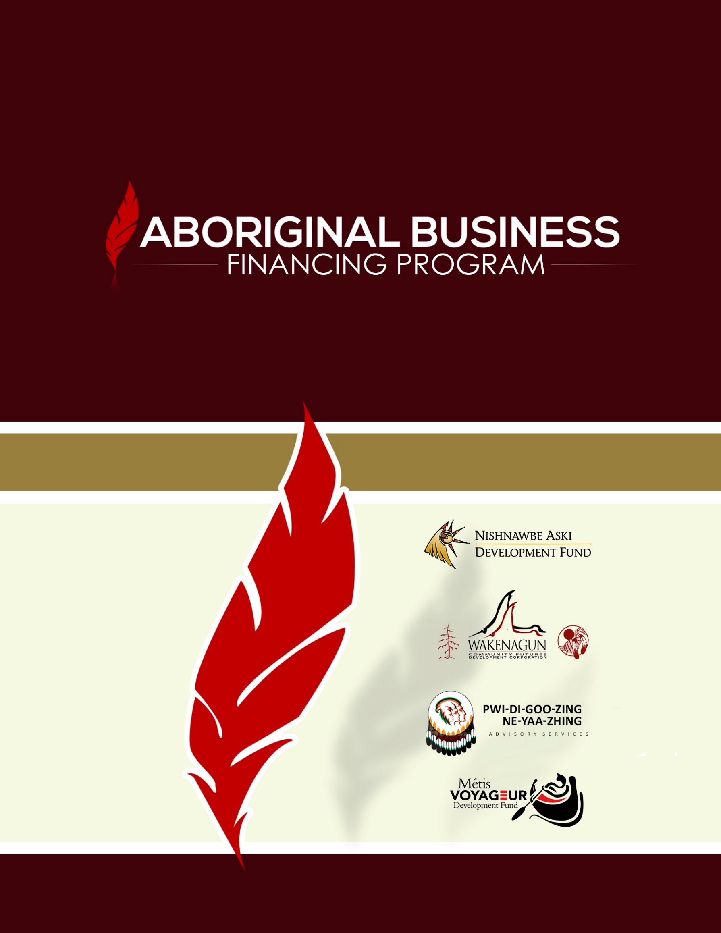

ABORIGINAL FINANCING

**APPLICATION FORM 2015/16**

Nishnawbe-Aski Development Fund

Aboriginal Business Financing Program

**Instructions for Completing your Application Form**

1. **Complete the Application**   
   The application Form allows us to determine eligibility for support available through Aboriginal Business Financing Program. Therefore, it is important that you answer all questions completely; use attachments and include any additional information that supports your proposal, such as business studies, market studies, financial statements and relevant industry information.
2. **Sign and Date the Application**   
   The application is not complete unless it is signed by someone with signing authority. In the case of small business, the owner may sign, if a corporation, this usually means someone with the authority to sign. For details, contact your Business Development Officer.
3. **Send the Application and supporting documents in**   
   Please submit the completed Application Form, including attachments, to the ABFP nearest you. Submit your application by;   
     
   **Mail or In Person to:**   
    106 Centennial Drive   
    Thunder Bay ON   
    P7E 1H3  
    -- or --   
    273 Third Avenue Suite 203   
    Timmins ON   
    P4N 1E2   
     
     
   **Email** Cory Robin – Business Development Officer ABFP   
    Timmins Office crobin@nadf.org   
    Lorraine Whitehead – Business Development Officer ABFP   
    Thunder Bay Office lwhitehead@nadf.org   
   **FAX**   
    807-622-8271
4. **Your Officer will go over the application**   
   before completing the assessment of your Application Form, a development officer will review the information in the document and contact you to discuss your proposal in more detail.
5. **Creating the Business Plan**Following the review and discussion of the information provided, and depending on the nature of your application, you may be asked to supply a comprehensive business plan. The size and complexity of the plan is based on the size and complexity of your project.
6. **You Must Be Willing to Work Full Time**   
   To be eligible for support, the applicant should be involved full-time with the proposed business in a management capacity.
7. **Submit All Required Documents**   
   When sending in your completed Application Form, please ensure you have included the following:

Evidence of Aboriginal ancestry, which includes status or Metis cards;

Evidence of sufficient personal financial resources to undertake the project you are proposing, e.g. a bank statement;

A resume that highlights experience, training and/or education related to your business activity;

For existing business, a copy of the past three years of financial statements;

Any additional information that supports your proposal, such as business studies, market studies or relevant industry information; and

A copy of any partnership agreements or incorporation documents.

Failure to provide these documents with your application Form will cause delays in assessing your project.

# Funding Levels

* Individual entrepreneurs may receive contributions up to a maximum of $99,999.
* Community owned business may receive contributions up to a maximum of $249,999

In order to determine eligibility, and assess your request for financial assistance, Aboriginal Business Financing Program is authorized to collect limited personal information, including the following:

* We require documented proof of Aboriginal Ancestry
* We collect the date of birth of applications to establish their eligibility for youth entrepreneurial support and to facilitate the completion of a credit check that may be required as part of our assessment
* We collect gender of application for statistically purposes only, to allow us to report on the demographics of our client base.
* We collect the education/experience of applicants to help us assess their collective business and management experience.
* We collect personal financial information of applicants to help us assess their ability to contribute capital and obtain commercial financing.

All information provided as part of the Application Form is subject to the provisions of the Access to Information Act and Privacy Act, and will be treated accordingly. All personal information collected will be retained for six years from the project completion date

Aboriginal Business Financing Program

Application Form

To help us without information and marketing efforts, please tell us where you learned about Aboriginal Business Financing Program (ABFP).

# I learned about ABFP from: (Check all that Apply)

Advertising Conference, Workshop, Tradeshow

Business Contact Aboriginal Affairs and Northern Development Canada

From my First Nation Past/Current Client

www.NADF.org Nishnawbe-Aski Development Fund

Other Website: Enter Details

Other: Enter Details

# A: Applicant Information

Applicant Legal Name: Business Operating Name:

Click here to enter text. Click here to enter text.

Mailing Address: Business Address (if different from mailing address)

Street: Click here to enter text. Street: Click here to enter text.

City, Prov: Click here to enter text. City, Prov: Click here to enter text.

Postal: Click here to enter text. Postal: Click here to enter text.

Telephone and Facsimile Numbers Email Address

Residence: Click here to enter text. Click here to enter text.

Business: Click here to enter text.

Cell Phone: Click here to enter text.

Facsimile: Click here to enter text.

Ownership Information

Owner(s) Ancestry Gender %Ownership Date of Birth

Owner Ancestry Gender %Ownership dd/mm/yyyy

Owner Ancestry Gender %Ownership dd/mm/yyyy

Owner Ancestry Gender %Ownership dd/mm/yyyy

Owner Ancestry Gender %Ownership dd/mm/yyyy

## Education Experience

For each owner, please attach a resume, outlining education, training and employment history along with management experience. Summarize how the education/experience relates to this proposal.

|  |
| --- |
| Click here to enter text. |

## Summary of (Owner’s) Net Worth

If business has multiple owners, please submit a separate personal statement of net worth for each.

|  |  |  |  |
| --- | --- | --- | --- |
| Assets | $ | Liabilities | $ |
| Cash/Bank Balance (attach confirmation) | Value | Charge Accounts Balances | Value |
| Real Estate | Value | Mortgages | Value |
| Equipment | Value | Loans Outstanding | Value |
| Vehicles | Value | Vehicles | Value |
| Other: Specify | Value | Other: Specify | Value |
| Total Assets (A) | Value | Total Liabilities (B) | Value |
| Net Worth | | | Value |

# B: Project Information

I am seeking assistance for

Start or acquire a business

Youth entrepreneur (aged 18-35)

An existing business

First Nation community-owned/based business

## Describe the Project

What product or service will you be providing, or are currently providing? Identify your current and/or existing target marketing and any existing competitors. Attach any additional information that helps support your proposal, such as business studies and relevant industry information.

|  |
| --- |
| Click here to enter text. |

## Is this project located in a Fist Nation Community?

Yes First Nation: Click here to enter text.

No

## Structure of Business

Individual/Sole Proprietor

Corporation

Partnership

Joint Venture

Other (Specify): Click here to enter text.

Please note that business and organizations must be majority Aboriginal-owned and controlled.

## Estimated Project Costs and Financing

Please itemize major projected expenditures, and set out the proposed financing package. Total Project Costs must equal Total Project Financing. These are estimates only and are intended to provide ABFP with information on the expected size and scope of your project.

|  |  |  |  |
| --- | --- | --- | --- |
| **Estimated Project Costs** | **$** | **Estimated Project Financing** | **$** |
| **Business planning or Support** | Value | Minimum Applicant Cash Equity  Required   * Business Plans/Business Support: 25% of Cost * Capital and operating;  Youth (under 35) 10%, Others 15% |  |
| **Capital** |  | Aboriginal Business Financing Program  ABFP | Value |
| Land | Value |
| Building | Value |
| Equipment | Value |
| Inventory | Value | **Commercial Financing**  Details:  Click here to enter text. | Value |
| Other (Specify)  Click here to enter text. | Value |
| Other (Specify)  Click here to enter text. | Value |
| **Operating** |  |
| Insurance | Value | **Other Government Assistance**  Details:  Click here to enter text. | Value |
| Utilities | Value |
| Other (Specify)  Click here to enter text. | Value |
| **Marketing** | Value |
| **Business Support** | Value |
| **Total Estimated Project** | Value | **Total Estimated Project Financing** | Value |

## Sources of Commercial Financing

Please identify the contact person and telephone number of financial institutions, government organizations or others you have approached to finance this project.

|  |  |  |
| --- | --- | --- |
| **Contact Person** | **Telephone Number** | **Organization** |
| Click here to enter text. | Click here to enter text. | Click here to enter text. |
| Click here to enter text. | Click here to enter text. | Click here to enter text. |
| Click here to enter text. | Click here to enter text. | Click here to enter text. |
| Click here to enter text. | Click here to enter text. | Click here to enter text. |

# C.) Other Information

1. Have you, or any other business that you own or have previously owned, received financial assistance from the Government of Canada. If yes, please describe.  
    Yes Details: Click here to enter text.  
    No
2. Are you applying to any other government programs for financial assistance for this project? If yes, please describe.  
    Yes Details: Click here to enter text.  
    No
3. Do you, or your business, awe money to the Government of Canada? If yes, please indicate to which department or agency and list amounts.  
    Yes Details: Click here to enter text  
    No
4. Have you already made any financial commitments to this project? If yes, please list amounts (s). **NOTE: Any costs for which you have make a legal commitment prior to project approval will not be eligible for Aboriginal Business Financing Program (ABFP).** Yes Details: Click here to enter text  
    No

# D.) Declaration

Note: Each Applicant must sign and date this Application Form

To: Aboriginal Business Financing Program (ABFP)

The statements herein and the attachments hereto reflect an accurate description and estimate of costs regarding the intended project.

I (WE) authorize duly appointed representatives of ABFP to obtain from and share with persons or organization, public or private, any information necessary to complete the assessment of the project outlined in this Application Form.

I (WE) consent Aboriginal Business Financing Program (ABFP) sharing my (our) name(s), phone number, and e-mail address with third party services providers (who are required to safeguard the handling of this information under the Personal Information Protection and Electronic Documents Act (PIPEDA) and/or the Privacy Act) for statistical, research and evaluation purposes for the Aboriginal Business Financing Program.

I (WE) declare that if I (WE) have used or are using the services of a lobbyist for the purposes of my (our) application for financial assistance, the lobbyist(s) is (are) in compliance with the Lobbyists Registration Act.

|  |  |
| --- | --- |
| Signature | Date |
| Signature | Date |
| Signature | Date |