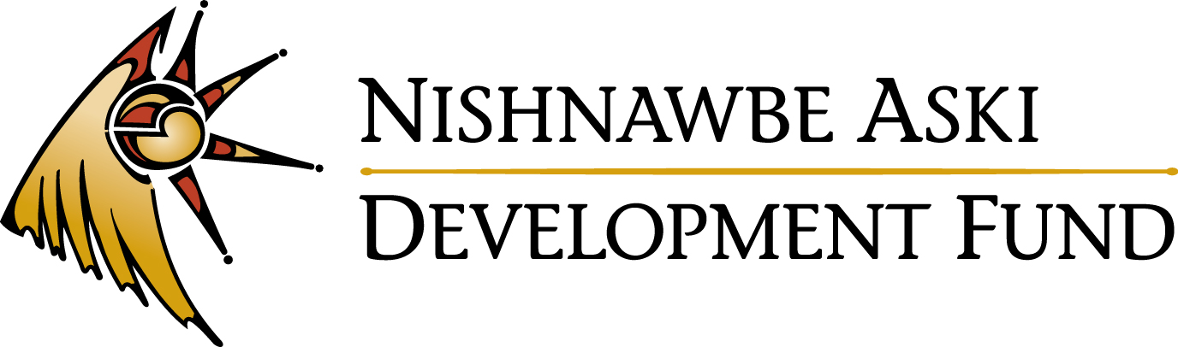

External Job Posting
Business Support Officer
Thunder Bay

Nishnawbe Aski Development Fund (NADF) has an exciting opportunity in our Thunder Bay office for a Business Support Officer. The Business Support Officer provides business support services to clients of Nishnawbe Aski Development Fund (“NADF”) under the direction of the Loans Manager.
DUTIES AND RESPONSIBILITIES:
- Deliver business support services and activities including, but not limited to:
- Investment: Intake/assessment of the client’s current situation, verification of equity for business start-up, assessment of financials for business expansion request, completion of statement of intent with client, and counsel clients on the process for loans and grants;
- Business Counselling: Assist clients with business plan development and, if appropriate, recommend changes and advise as to the feasibility of ideas.
- Organize and deliver business training and development workshops.
- Prepare reports on activities or projects as required.

QUALIFICATIONS:
- A post-secondary diploma in Business or Accounting or a degree with significant business experience of more than three (3) years.
- Experience working within aboriginal communities or with aboriginal clients would be an asset.
- Strong accounting, business planning and business management skills.
- Strong written and verbal communication skills including demonstrated ability to write reports and proposals.
- Strong public relations skills.
- Computer literacy including e-mail, word-processing, accounting, database and spreadsheet software.
- Knowledge of and commitment to the services provided by NADF.
- Knowledge of the people, culture, and history of Nishnawbe Aski Nation; in-depth knowledge of the economic climate and business development priorities of the First Nations in NAN.
- Ability to speak Cree, Oji-Cree, or Ojibway would be considered an asset.

Salary range is $32,921 - $41,672 commensurate with qualifications and experience. To review a complete job description, please visit our website at www.nadf.org.

Qualified applicants may forward their cover letter and resume with three (3) work related references by Friday, August 28, 2015, by 4:30 p.m. (EDT):
Nishnawbe Aski Development Fund
Attn: Millie Carpenter, HR Manager
107-100 Anemki Drive
Fort William First Nation, ON P7J 1J4
Fax: (807) 622-8271
Email: mcarpenter@nadf.org

While all responses will be appreciated and handled in strictest confidence, only those applicants being considered for an interview will be contacted. Members of Nishnawbe Aski Nation are encouraged to apply.

