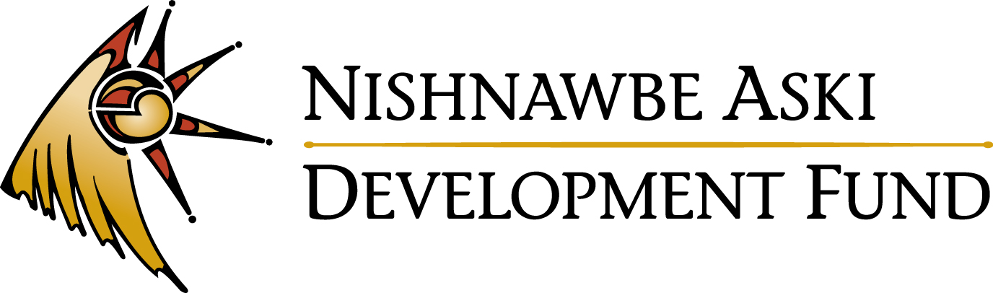

External Job Posting
Micro Loans Coordinator
(Up to Five (5) Month Contract)
Thunder Bay

Nishnawbe Aski Development Fund (NADF) has an exciting opportunity in our Thunder Bay office for a Micro Loans Coordinator. The Micro Loans Coordinator will research existing micro-lending projects and implement a micro-lending model in remote First Nations in the Nishnawbe Aski Nation territory.

DUTIES AND RESPONSIBILITIES:
The Micro Loans Coordinator will be responsible for the following duties:
- Deliver support for women interested in developing and maintain micro lending circles within First Nations in the Nishnawbe Aski Nation territory.
- Deliver two (2) – three (3) days entrepreneurship training in First Nations, prepare teaching material to includes relevant business topics, prepare handout exercises. Provide certificates of completion to participants who have attended most of the eight (8) – ten (10) hour training sessions.
- Organize and plan visits to First Nations with a clear schedule of training available to women, to encourage participation.

QUALIFICATIONS:
- A post-secondary diploma and/or a degree in Business and/or Accounting, or a minimum of 4 to 6 years small business experience.
- Strong written and verbal communication skills including demonstrated ability to write reports and proposals.
- Strong financial analysis and business assessment skills.
- Strong public relations skills.
- Knowledge of and commitment to the services provided by NADF.
- Knowledge of the people, culture, and history of Nishnawbe Aski Nation; in-depth knowledge of the economic climate and business development priorities of the First Nations in NAN.
- Ability to speak Cree, Oji-Cree, or Ojibway would be considered an asset.

Salary range is $38,156 - $48,299 commensurate with qualifications and experience. To review a complete job description, please visit our website at www.nadf.org.

Qualified applicants may forward their cover letter and resume with 3 references by Friday, July 17, 2015, by 4:30 p.m. (EDT): Nishnawbe Aski Development Fund
Attn: Millie Carpenter, HR Manager, mcarpenter@nadf.org
107-100 Anemki Drive
Fort William First Nation, ON P7J 1J4
Fax: (807) 622-8271

